Officers Report
Ash Sturrock

Senedd
01/11/2022
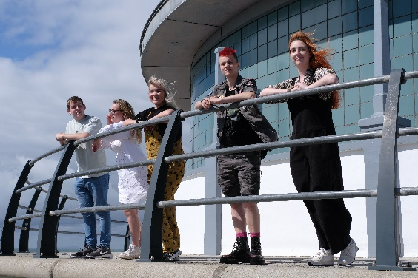
Summary:
It has been amazing seeing all the new and returning students coming back to Aberystwyth and enjoying the year so far. Freshers was great with amazing turn outs to our night-time events as well as our meet and greets. We are so excited to jump into this year with some amazing events and campaigns planned all the officers hope students will love.
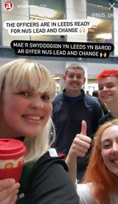
Our first month in the role was based around training the officers for the roles and responsibilities as well as planning out our objectives for the year. The officer team travelled to Leeds for Lead and Change to help us grow as officers and plan out campaigns for the year. This was an amazing time to understand our jobs for the year as well as bring us closer as an officer team. This helped us work as a team to be able to organise Freshers.
We sit on different committees and boards across the university such as Council, Senate and Academic Board to ensure your student voices are heard. It’s been super interesting to engage with these committees in person after meeting strictly online for the first couple of months. I was also able to do a presentation at the Senedd conference with the university and talk about sustainability in the university.

Helo Aber – Freshers Week
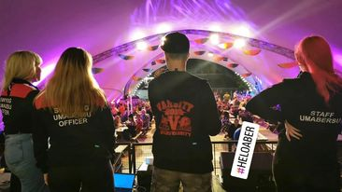
Freshers was a huge success for us. Students and staff enjoyed themselves and it was a great introduction to university life. We would all like to say a huge thank you to the opportunities team for all their hard work they put into running Freshers Week.
Our officer quiz kicked off the week and we were so excited to see how many students showed up. It was really fun to run, and we had a great time – especially seeing the officers faces on famous movie posters. We spent the rest of the week promoting events and meeting students in the freshers fair.

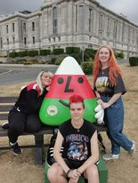
We also organised numerous meet and greets for students historically marginalised in higher education throughout the week including LGBTQ+, Women’s and Postgrad. We got to enjoy a wine and cheese night. All of these meet and greets were a great success and we want to say thank you to all the officers and union staff members who helped run the events.

New Staff
We had to say a very sad goodbye to Al this year who was our Campaigns and Democracy coordinator. However, they are going on to do some amazing things and the whole Students Union is very proud of them.
We have also had several new staff members this year! We have introduced Jacob to our team as the new head of student voice and Jessica who is our new Media, Sales and Events coordinator. We also have Kit who is our new Reception and Finance coordinator. We are also welcoming Chloe to our team who I maternity cover for the communications Coordinator. We are supper happy to welcome them all to our team.
Ash – President
So far this year I have been working on my objectives, starting out my campaigns and planning events. I have been organising my SHAG campaign to make students have more confidence and awareness about sexual liberation. I have been organising events for the week to educate the community of different types of sex as well as empowering classes to make you feel more comfortable in your body. I have been working with a number of current and ex-students on issues they care about and reducing stigmatisation around kink and sex work.
I have also been working on another one of my objectives which is Green Impact. I want to make sure our union and university is thriving with sustainability and making sure we are progressing with environmental impacts. I have been working with the university to make changes within the university as well as in the union. I have been in contact with the local county council about the issues of rubbish in town. This has led me to start up a smaller campaign, linked to green impact called that’s a rubbish campaign to try and tackle the issues of rubbish on the streets in Aberystwyth. Currently, I have shot a video interview with the council about rubbish that will be available to view shortly.
I have also been working closely with the union and university to help students in the cost-of-living crisis. The union now has a free hub where students can collect items for free such as clothing and plates etc. We also have the essential hub where students can collect food and toiletries completely for free to help them keep themselves happy. As well as this, are community kitchen is being set up for students to use. I have now started to work with the Vice Chancellor on ways the university and union can work together to support students as much as possible through the cost-of-living crisis.
A well as all this, there has been some exciting things the union has been able to get involved in. The union has joined with Mind out Future which is a lottery funded project trying to make mental health provision in our county better for 4–25-year-olds. We have also attended 150 years founders’ day celebrations with the university, and I was able to talk to the shop located in the Students Union about a meal deal which has now been introduced. So far this year, some really exciting things have been happening and I hope students are able to get the best out of them.
Dafi – UMCA President and Welsh Culture Officer
Dafi has been working on events for the UMCA calendar such as Freshers week events and swn, making sure all his events are fun and entertaining. He has been working on making UMCA and the Welsh community more accessible for learners with more accessible social media posts and hosting learners lounge at all events to promote the use of the language. Dafi is looking forward to UMCA’s 50th anniversary next year and will be happy to receive any potential ideas for what the Union can do.
Rachel – Student Opportunities
Starting her second (and final ☹) year in the role, Rachel has selected the following as her priorities;
- Involve more international and culturally diverse (i.e. faith groups) students within the Tîm Aber Community
- Ensure facilities used for activities are appropriate and accessible for all students
- Continue to increase engagement with Tim Aber
Carrying on from last year, Give It A Go returned and it was amazing to see so many groups run sessions and see new and returning students get excited about trying out different activities. There has also been the introduction of a new room booking system and discussions with Student Services about the reinstatement of the Faith Space as a usable venue for students.
A policy win is that we have a new name for our Tîm Aber mascot! Following a public call out to a shortlist to a vote via a poll at Freshers Fair to now, we can introduce Idris to the world! We released the results as part of the Homecoming celebrations, which brought back alumni to Aber and contributed as part of Aberystwyth University’s 150th Celebrations.
Coming up next is a selection of key events so she is expecting to devote a lot of time towards those: Aber Challenge, #EmpowerAber (which is a new combined campaign for Rachel and Elizabeth to encourage women and marginalised genders to get involved in student life) and Arts Festival. She also has the first Sports and Societies Zone taking place next week which she is looking forward to as a venture of sharing her thoughts for the year ahead, as well as hearing new ideas.
Elizabeth – Academic Affairs
Elizabeth has been working on carrying over her priorities from last year. These include decolonising the curriculum, continuing to create a community for academic reps and to continue and solidify the postgraduate network she created last year, so that it can be carried on when her role is succeeded in July. In relation to decolonising the curriculum, Elizabeth will continue to work with the university on their race access project and has created posters to share her reporting form for students more widely, which will hopefully compliment the uni’s planned work with departments. Elizabeth is also planning a rep meet and greet and a rep conference to be held this month to bring all our reps together to meet each other and enhance their skills both inside and outside of their role. This is important for creating more a community amongst academic reps and therefore will hopefully increase their engagement. Elizabeth also hosted the first postgraduate meet and greet of the year, which saw 90 students attend and is excited to carry on the postgraduate network, which already has 40 more members than last year, making the numbers 181. She is grateful for the help from the graduate school in creating this network and also from the SU comms team in getting more postgraduate students involved with the student’s union and setting up a webpage for the network.
Cameron – Wellbeing Officer
Since starting his role as Wellbeing Officer in July, Cameron has attended a variety of meetings to raise, discuss, and understand issues that students are currently facing at university; written several blogs; ran and helped run a variety of activities; and have also been working towards achieving my objectives:
1. Provide free gender affirming products in the SU for trans and gender diverse students.
2. Increase fieldwork accessibility.
3. Improve the accommodation matching system.
He is making good progress on my first objective and the campaign will be up and running soon. For his second objective, he has had meetings with a variety of staff members in the university (department and Student Services staff) to talk about fieldwork accessibility and EDI (equality, diversity, and inclusion) to better understand their processes and concerns. In these meetings, they have talked about how fieldwork could be made more accessible for autistic students, he has raised the issue that neurodiverse and gender diverse students may face challenges with fieldwork that people may not think of, and they have talked about how we need to improve the relationship between staff and students so that students feel comfortable enough to disclose their needs in order to enjoy fieldwork. Cameron has also written a blog which shows how people face different challenges with fieldwork. Their final objective has been somewhat completed with Accommodation introducing their new student matching system.
Aside from his three priorities, Cameron has helped run meet and greets (LGBT, trans, and disabled); written several blogs talking about personal topics (asexuality, Tourette Syndrome, OCD, and what it’s like being transgender) in order to educate and liberate students and staff; and helped organise guide dogs and Dyfi donkeys for exam destress. They attended a meeting with Padarn Surgery’s new manger and spoke about trans students and how difficult it is to change you name with them which had a very positive outcome. He is currently putting together a Tourette’s talk and Q&A for Disability History Month which will cover what Tourette Syndrome is, the history behind it, and his story to educate and liberate students and staff. To encourage students to share their accessibility needs, they are hoping to push staff across the university to share their stories about their disability and/or neurodiversity. In addition, Cameron is helping Student Services put together a trans information page which will cover a variety of challenges that trans students may face and how to tackle them.

